**Zinkworks ATM Assignment**

### **Information**

I took the approach of coding the application and business logic in Java code. I understand there is probably more efficient ways to implement this i.e. frameworks but I decided to approach this in what I was most comfortable with which is Core Java. I hope this illustrates a good fundamental knowledge of Java and technical capacity that I have the aptitude to learn and broaden my skill set to meet project needs. Thank you very much for taking the time to review.

**Some Screenshots**

Ran on local Tomcat Server

Using GET – for browser support as per Requirements (also supports POST)

Request Account Summary – Invalid Account:

http://localhost:8080//ATMJavaApp/requestAccountSummary?accountNumber=1234&pinCode=2233

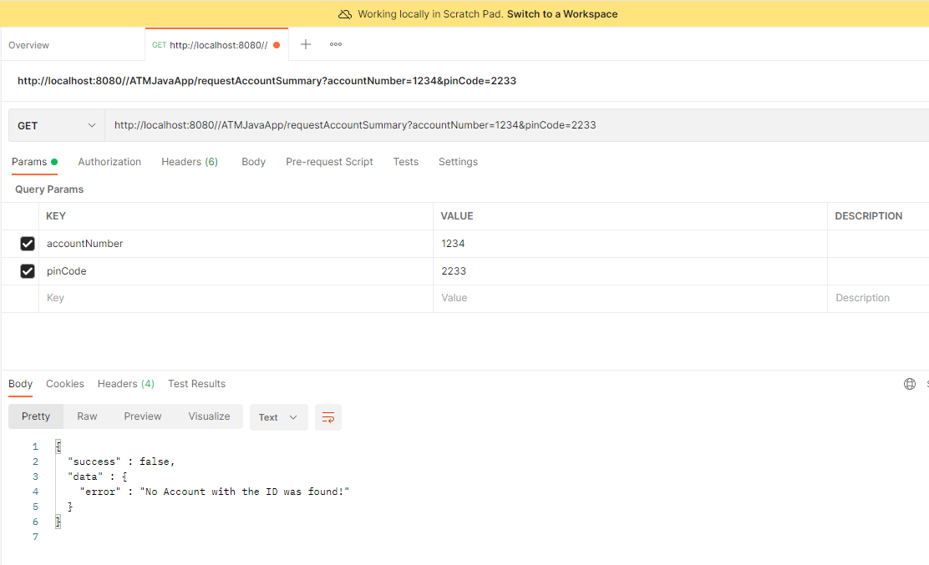

Request Account Summary – Good Account but incorrect PIN

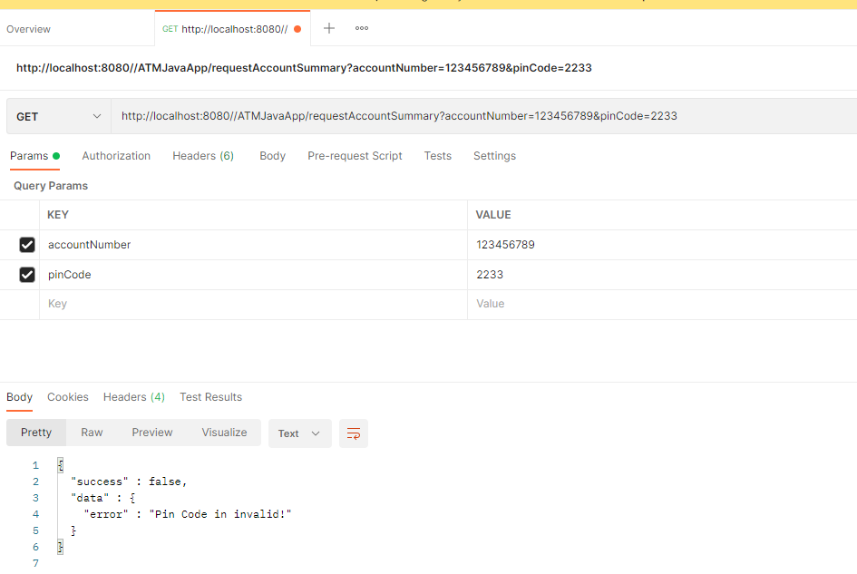

Request Account Summary – Good Account but bad PIN again – not numeric

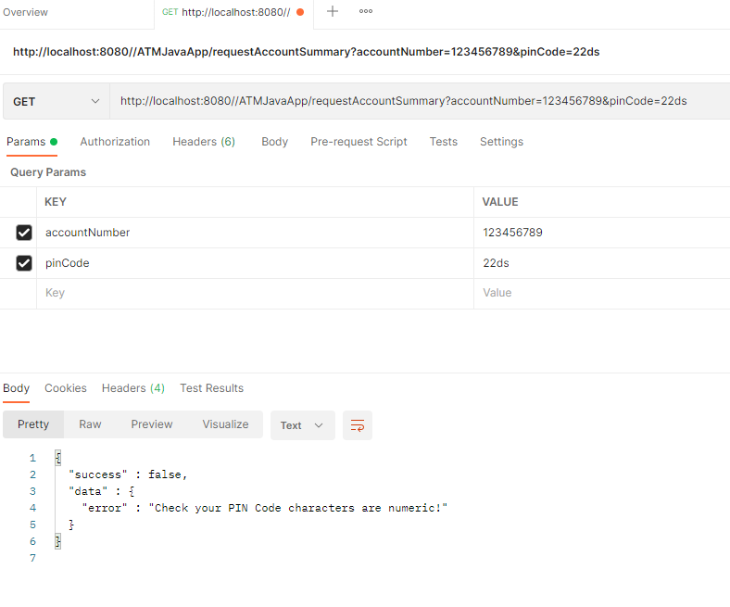

Request Account Summary – Good Account and PIN

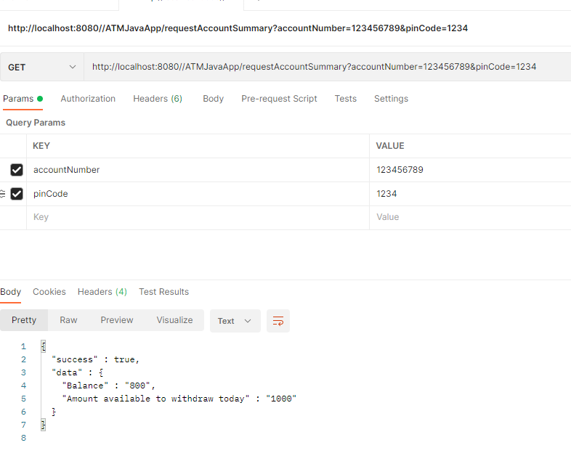

Request Withdrawal – Valid info

<http://localhost:8080//ATMJavaApp/requestWithdrawal?accountNumber=123456789&pinCode=1234&withdrawal=335>

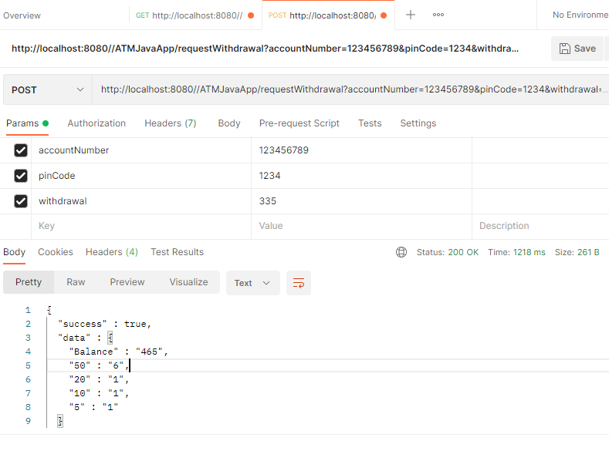

Request Account Summary – Good Account and PIN – expect updated balance and withdrawal (balance plus overdraft).

